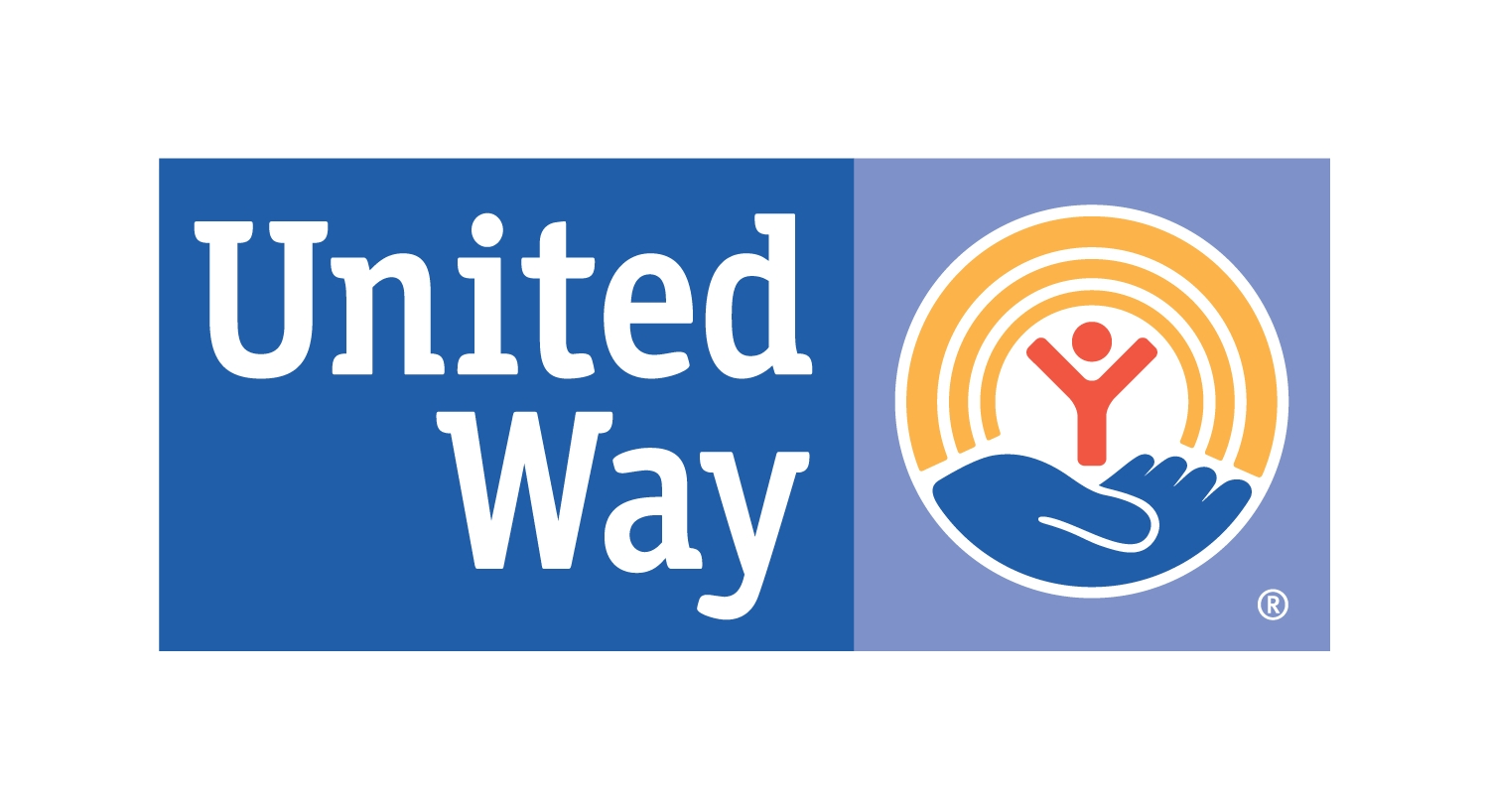
UNITED WAY OF WESTERN NEBRASKA
CODE OF ETHICS

MISSION STATEMENT
To united people and resources of Western Nebraska to build a stronger, healthier and more compassionate community.

MERIT STATEMENTS
- To promote peoples’ abilities to care for one another
- To conduct fund raising activities with proceeds to be distributed to area health & human service agencies
- To allocate funds to are health & human service agencies in a fair manner
- To support volunteer services within Western Nebraska
- To support community planning efforts to enhance area health & human service delivery
- To provide educational opportunities which enhance and support area health & human service agencies
- To maintain appropriate practices and procedures within the United Way of Western Nebraska organization
- To continually evaluate processes to determine effectiveness of activities

DONOR RIGHTS
- You have the right to know our mission and purpose and to become a member of our organization if you so choose
- You have the right to know our officers and members of the Board of Directors and to expect that they act with the greatest integrity and clear-sightedness in enforcing the organization’s mission and purpose for the best interest of the community
- You have the right to ask and receive a copy of our annual financial statement
- You have the right to confidentiality regarding personal information about donors and facts about their donations
- You have the right to expect that all relationships between the organization’s representatives and the donor will be professional in nature
- You have the right to know how donations are distributed, and to be assured that United Way uses donated funds as intended
- You have the right to be treated with consideration and respect by the organization and to receive the appropriate acknowledgment and recognition
- You have the right to expect that United Way will not share or sell donor information at any time
- You have the right to ask questions of us and expect to receive a prompt, truthful and complete answer

FUNDRAISING PRACTICES CODE OF ETHICS
Solicitation for fundraising on behalf of the United Way of Western Nebraska will be truthful, accurately describing the United Way of Western Nebraska’s activities and the intended use of donated funds. We will also respect the dignity and privacy of those who benefit from the United Way of Western Nebraska’s activities.

Employees who solicit or receive funds on behalf of the United Way of Western Nebraska shall adhere to the provisions of this Fundraising Practice Code of Ethics. They will act with fairness, integrity and in accordance with all applicable laws, as well as adhere to the provisions of applicable professional codes of ethics, standards of practice, etc. They will cease solicitation of a prospective donor who identifies the solicitation as harassment or undue pressure and will disclose immediately to the United Way of Western Nebraska an actual or apparent conflict of interest. And finally, they will not accept donations for the purposes that are inconsistent with the United Way of Western Nebraska’s objectives or mission. They will not sell, rent or otherwise exchange the United Way of Western Nebraska’s donor list. The governing Board will be informed at least annually of the number, type and disposition of complaints received from donors or prospective donors about matters that are addressed in this Fundraising Practices Code of Ethics.

VOLUNTEERS CODE OF ETHICS
As a volunteer, I realize that I am subject to a code of ethics similar to that which binds the professionals in the field in which I work. Like them, I assume certain responsibilities and expect to account for what I do. I will keep confidential matters confidential.

I promise to take to my job an attitude of being very careful and exacting; to be willing to be trained for it; to bring to it interest and attention. I realize that I may have assets that my co-workers may not have and that I should use them to enrich the project on which we are working together. I realize also that I may lack assets that my co-workers have, but I will not let this make me feel inadequate, but will endeavor to assist in developing good teamwork.

I plan to find out how I can best serve the activity for which I have volunteered and to offer as much as I am sure I can give, but no more, I realize that I must live up to my promises and, therefore, will be careful that my agreement is so simple and clear that it cannot be misunderstood. I believe that my attitude toward volunteer work should be professional. I believe that I have an obligation to my work, and to those who direct it, as well as to my colleagues and those for whom it is done, and the public.

Being eager to contribute all that I can to human betterment, I accept this code of ethics for volunteers as my code to be followed carefully and cheerfully.

DIVERSITY AND EQUAL OPPORTUNITY
Value, champion and embrace diversity in all aspects of United Way of Western Nebraska activities. United Way of Western Nebraska respects others without regard to race, religion, color, sex, age, national origin or ancestry, marital status, veteran status, sexual orientation, or status as a qualified disabled or developmentally challenged individual.

CONFLICTS OF INTEREST
United Way of Western Nebraska staff shall avoid any activity or outside interest which conflicts or appears to conflict with the best interest of United Way of Western Nebraska, including involvement with a current or potential United Way of Western Nebraska vendor, grantee, or competing organization unless disclosed to and not deemed to be inappropriate by the United Way of Western Nebraska Board of Directors.

POLITICAL CONTRIBUTIONS
United Way of Western Nebraska will refrain from engaging in political activities in any manner that may create the appearance that such activity is by or on behalf of the United Way of Western Nebraska.

